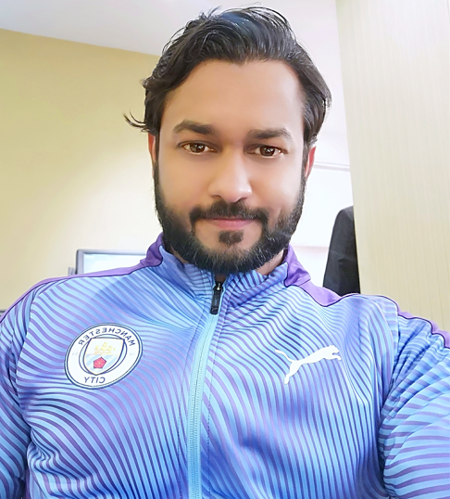  *CONTACT*  Address:  House # H I06/10 Nashtar Squire Malir Colony Karachi Pakistan.  Phone:  +92-341-2645366  +962-799314220  Email:  ia5073735@gmail.com  P.O.BOX : 75080  *PERSONAL*  Father’s Name:  Ali Hassan  Date Of Birth:  8th August 1987  CNIC No. :  42201-8126135-5  *COMMITMENT*  Believes in smart working and punctuality as it is the key to success. | *IRFAN ALI*  *OBJECTIVE*  Seeking a challenging career where my academic excellence & experience will be added value towards organization and personal growth.  *EDUCATIONAL QUALIFICATIONS*  - (MBA) Master of Business Administration from (SBS) Singapore Business School.  - (DAE) Diploma Association Engineer in (Advanced Principle of Industrial Engineering) from Alison’s Institute.  - Intermediate with (Commerce) from Karachi board of Pakistan.  - (DAE) Diploma Association Engineer in (Textile) from Technical Board of Karachi Pakistan.  - Matriculation with (Computer Science) from Karachi board of Pakistan.  *OTHER QUALIFICATIONS*  - Lean Six Sigma Manufacturing Course.  - (GSD) General Sewing Data Course.  - Merchandising Course.  - English Language Course at (Professional Level) from (ALC) American language center.  *STRENGHTS & SKILLS*  - Good understanding of engineering with experience in (Soorty Enterprises PVT, LTD).  - Good understanding of Lean manufacturing with experience in (Soorty Enterprises PVT, LTD) & (Rainbow Textile LLC Jordan).  - Good understanding of GSD with analyses in Soorty Enterprises PVT, LTD.  - Good working skills on software like Pro Engineer and Auto cad.  - Ability to think outside the paradigm to deal with specific situations.  - Possess good people skills and can work effectively and efficiently as part of a team.  *COMPUTER SKILLS*  - MS Office Excel.  - MS Office Word.  - MS Office Power Point.  - Mailing & Internet.  - ERP Oracle.  *WORK EXPERIENCE *  *RAINBOW TEXTILE LLC (JORDAN)*  Duration: 23 Augest,2017 till 9 December 2023  - Worked as a Senior Industrial Engineer: Responsible for the people and team management.  - Communicate with the customer about technical issues.  - Communicate with R&D department for product development.  - Responsible for technical comments about product.  - Responsible for looking after start to ship process.  - Counseling & Teaching to the people.  - Skills management and sharing.  - Increase productivity & efficiency.  - Process improvement, Method & Motion improvement.  - Automations & Innovation.  - Make layouts of products, calculate material’s consumption.  - Reduce costing & remove the wastages from the organization by applying lean process.  *SOORTY ENTERPRISES (PVT)LTD*  Duration: 14 June,2016 till 22 August 2017  - Worked as a Senior Lean officer: Responsible for counseling and teaching the Lean manufacturing process.  - Apply the lean process and remove the unnecessary wastages from organization.  - Responsible for people and team management.  - Responsible for the process improvement.  - Improve productivity & efficiency of the organization.  - Responsible to make product (merging) and flow layout.  - Reduce costing.  *SOORTY ENTERPRISES (PVT)LTD*  Duration: 5 December,2013 to 14 June 2016  - Worked as an Industrial Engineer: Responsible to make layouts.  - Responsible for pre-production planning.  - Responsible to arrange all necessary equipment.  - Calculating material’s consumption.  - Increase productivity and efficiency.  - Improve the process.  - Automation and innovations.  *SOORTY ENTERPRISES (PVT)LTD*  Duration: 1st July,2013 to 5 December,2013  - Worked as an Assistant of production Manager: Responsible to make production plan.  - People and team management.  - Production floor and line balancing.  - Follow up with in charges and supervisors about production.  - Responsible to communicate with other departments.  - Responsible to make production report.  *DELUXE PACKAGES PRINTING PRESS (PVT)LTD*  Duration:8th june,2012 to 29th May,2013  - Worked as an Admin Officer: Responsible to communicate with people.  - Responsible to communicate with supplier and contractor.  - Responsible to arrange necessary equipment and things.  - Responsible to make inward and outward get pass & all the computer work.  *QASIM TEXTILE DENIM MILLS (PVT)LTD*  Duration: 3rd May,2011 to 15 April,2012  - Worked as an Assistant Quality Control: Responsible to inspect the fabric quality of finish goods.  - Responsible to achieve production with quality.  - Responsible to make quality reports.  - Responsible to make the dispatch reports.  *E_DATA CALL CENTER*  Duration: 06 Months.  - Worked as a phone operator: In the customer service center responsible to handle the customers.  - Generate the customer reports.  *INTERESTED*  - Engineering Management.  - Project Management.  - People and Team Management.  - Lean Manufacturing.  - Process Improvement.  - Production & Efficiency Improvement.  - Automation & Innovation.  - Reduce Costing.

