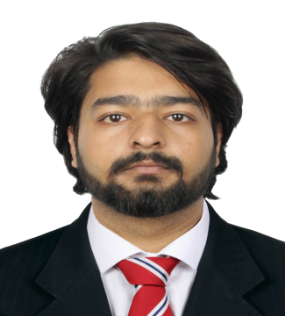
SAHIBZADA GHULAM MUSTAFA SIKANDAR

Accountant/ Cashier

+971 558468046
Visa Status Visit
Valid Till-17th Jan 24
mustafasialvi80@gmail.com

EDUCATION

Master Of Commerce (M.com)

University of Sarghoda (UOS)
2021 - 2023

Bachelors of Commerce (B.com)

University of Sarghoda (UOS)
2019 - 2021

FSC (Pre Engineering)

ABOUT ME

Experienced accountant/Cashier with a background spanning Two years. Demonstrates proficiency in utilizing QuickBooks and Excel for comprehensive financial management. Specializes in adept bookkeeping, precise bank reconciliation, and meticulous preparation of financial statements. Recognized for keen attention to detail, effective time management, and a commitment to meeting deadlines. Possesses strong communication and collaboration skills..

WORK EXPERIENCE

Punjab Group Of Colleges
2016 - 2018

Book keeper
EZ Advisory | Pakistan
Good Engineering Works (Pvt) Ltd.
2021 - 2023

EXPERTISE

QuickBooks Online MS Excel
Google Sheets MS POWERPOINT MS WORD
ATTENTION TO DETAILS CRITICAL THINKING LEADERSHIP

LANGUAGES
During my one-year tenure as a bookkeeper for clients Al Abbasi and Extreme Panels, I have developed invaluable skills through a structured progression:
- Initial Focus (Months 1-3):
Mastered the financial systems of the company.
Acquired a deep understanding of specific bookkeeping procedures.
- Efficient Account Management (Months 4-6):
Effectively managed accounts payable and receivable.
Maintained precise and organized records of financial transactions.
- Skill Refinement (Months 7-9):
Honed bookkeeping skills, including financial analysis.
Ensured the accuracy of records through meticulous attention to detail.
- Budgeting and Complex Challenges (Months 10-12): Played a pivotal role in the budgeting process. Successfully tackled intricate bookkeeping challenges.
Throughout this year-long journey, I have significantly enhanced my proficiency in bookkeeping software and consistently demonstrated an unwavering commitment to accuracy in the meticulous maintenance of all financial records.
- Having a Two year Experience Of Cash Handling at Good Engineering Works (Pvt) Ltd.
- And Customer Service certificate From Good Engineering Works (Pvt) Ltd.
- Issue Receipt etc.

CERTIFICATIONS

ENGLISH
URDU PUNJABI

MICROSOFT OFFICE SPECIALIST: EXCEL ASSOCIATES-
QuickBooks ONLINE CERTIFIED PROFESSIONAL-

QuickBooks ONLINE ADVANCED CERTIFIED PROFESSIONAL-
MULTIPLE ALISON COURSE-
2023
2023
2023
2023

