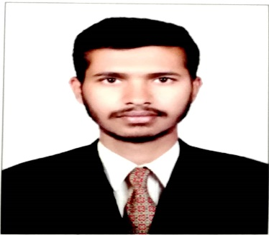

RAJSHEKER GIRMAI

Mobile:+971 0506565843

Email:rajashekargirmai66@gmail.com

CAREER OBJECTIVE

To be part of an organization where my potentials can be utilized to transform individual goals into organizational needs that offers both challenge and opportunities to grow. A team player who can adapt well to a new situation. Seeking opportunity where I do appreciate dedication and commitment.

POST APPLIED FOR

Dear Sir,

I am applying for SUITABLE JOB. I am very much interested to work in your company.

Present I am working as a RECEPTIONIST in ADNH.

EDUCATION

|  |  |
| --- | --- |
| **Academic** | **Grade** |
|  |  |
| SSC | 80% |
| +12 | 83% |
| PGDCA |  |
| BASIC COMPUTER COURSE | UAE |
| CERTIFICATE OF APPRECIATION | ADNOC |

**SKILLS**

**TECHNICAL**

* computer Literacy

**Languages:**

* **English:**Fluent
* **Hindi:** Fluent
* **Telugu:**Native

**Interpersonal**

* Teamwork Skills
* Able to communicate effectively with a wide range of people.
* Confident with professional speaking and presenting abilities.
* To be honest and to trust worthy in all my duties
* Positive attitude
* Have the ability to work for long hours
* Have the ability to work under pressure

**EXPERINCE**

* **Name of company :** Abudhabi National Hotels co.
* **Designation :** RECEPTIONIST
* **Duration :** 03/06/2017 till now
* **Place :** UAE

**Hobbies and Interests**

* Computing
* Reading Books
* Participating in Volunteer Work

Personal Data

|  |  |
| --- | --- |
| Father Name | Rajaiah Girmai |
| Date of Birth | 31/12/1997 |
| Gender | Male |
| Nationality | Indian |
| Marital Statuts | Single |
| Religion | Hindu |

Passport Details

|  |  |
| --- | --- |
| Passport Number | P1173181 |
| Date of Issue | 19/04/2016 |
| Date of Expiry | 28/04/2026 |
| Issue Place | Hyderabad |

DECLARATION

Hereby Declare That the Above-Mentioned Information Is Correct Up to My Knowledge and I Bear the Responsibility for The Correctness of The Above-Mentioned Particular.

(RAJSHEKER GIRMAI)