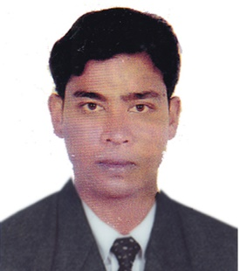 **Md. Shimul Biswas**

Mobile: **01966-155243**

E-mail: **bshimul19@gmail.com**

**Career Objective:**

Establish a sound background which will help to deal a challenging career where personally developed knowledge and skill as well as operations and service will help to bring quality in life.

**Educational Qualification**

**Title : Bachelor of Social Science (B.S.S)**

Institute : Bangladesh National University

Year : 2011

Result : 2nd Class

**Title : Higher Secondary Certificate (HSC)**

Group : Humanities

Institute : Rajapur Degree College, Natore

Year : 2008

Result : GPA- 3.00 out of 5.00

**Title : Secondary School Certificate (SSC)**

Group : Humanities

Institute : Gopalpur High School, Natore

Year : **2006**

Result : GPA- 3.56 out of 5.00

**Working Experience**

**Factory : MICRO FIBRE GROUP**

Designation : Junior Executive

Joining Date : 5th December 2015

Working area : Admin & ISO Procedure

Buyer : H&M, C&A, Magalink Tex. Miami.

Job Duration : 5 years

**Language Proficiency**

Excellent proficiency in speaking, writing & listening in both Bengali and English. Also able to understand Hindi.

**Computer Proficiency:**

Office Package : Microsoft Word, Microsoft Excel,

Operating System : Windows XP/windows 7/ windows 10/latest versions

**Personal Qualification:**

* Effective communication and strong interpersonal skills. Punctual, hard-working, self-motivating and proactive.
* Confident to lead and comfortable to work as a part of a team.
* Good ethical consideration, goal-oriented and willing to learn extensively.
* Have the abilities in organizing and conducting seminars, multimedia presentation and report writing.
* Ability to take responsibility.
* Efficient in documentation, writing & technical reports.

**Personal Detail**

Name : Md. Shimul Biswas

Father’s Name : Md. Abdul Jalil

Mother’s Name : Joynab Begum

Present Address : Kutubpur, Fatullah, Narayangonj-1400

Permanent Address : Shibpur, Gormati, Baraigram, Natore

Religion : Islam

Marital Status : Married

Language Efficiency : Bengali & English

Hobbies : Reading, Meeting friends, Travelling,.

Attributes : Hard working, Committed, Ability to work in

group, Ability to learn quickly, Willingness to

accept direction, Ready to work in any active

Environment.

**Declaration**

I swear that the information given above is all absolutely true and if any lie found I would be responsible for that.

**Signature:**

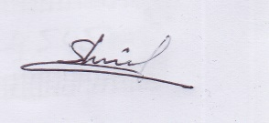

**Md. Shimul Biswas**